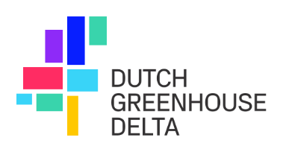

Registration form
SMM-China activities April 2026

We are excited to invite you to participate in the following SMM-China activities:
- Sino-Dutch Horticulture Seminar & Project Launch, Zhenjiang, Jiangsu Province, on April 7 and 8.
- International Innovation and Rural Development Expo in Hefei, Anhui Province, on April 9.
- Joint NL Pavilion – China HortiFlor Expo IPM (including seminar) in Beijing, on April 10-12.
- Horticultural Roadshow – Shandong Province on April 13-15.

By registering, you secure your spot at the SMM-China activities and gain exclusive opportunities to connect with Chinese and Dutch companies in the horticultural sector.

Please fill out the form below to confirm your participation and send it to info@dutchgreenhousedelta.com:

Company name
Contact person
Position/title
Phone Number
Email Adress
Website
WeChat
Participation: | ☐ Sino-Dutch Horticulture Seminar & Project Launch, Zhenjiang, Jiangsu Province, April 7-8  ☐ International Innovation and Rural Development Expo in Hefei, Anhui Province, April 9  ☐ Joint NL Pavilion – China HortiFlor Expo IPM (including seminar) in Beijing, April 10-12  ☐ Horticultural Roadshow – Shandong Province, April 13-15
- Additional Requirements / Notes:
Payment information

Whether you choose to attend one activity or more, we are pleased to offer this unique opportunity at fee of €500 (excluding VAT) in total for all activities.

Invoice Name / Company Name
Billing Address
Email for invoice
VAT / Tax Number
Special Instructions / Reference

By submitting this form, you confirm your interest in joining one or more SMM activities. Our team will contact you with further details and next steps, including the payment process.

